**EXPERIMENT 9**

**Title:** Designing 3D objects using blender.

**Objective:** To design mountains using blender.

**Theory:**

Blender is the free and open source 3D creation suite. It supports the entirety of the 3D pipeline—modelling, rigging, animation, simulation, rendering, compositing and motion tracking, video editing and 2D animation pipeline. The latest version can be found on www.blender.org

**Procedure:**

**Step 1:** Open up Blender and delete everything if you want.

**Step 2:** We need to use a plugin that will generate mountains for us. So go to File -> User Preferences -> Add-ons.

**Step 3:** Look for (or type in) the addon ‘ANT Landscape’. Enable by checking the box on the right (near the scared-looking human figure).

**Step 4:** Close the User Preferences window.

**Step 5:** Now add the landscape by Shift+A -> Add -> Landscape. You should now have your own little mountain!

**Step 6:** But wait! Don’t do anything with the mountain yet! You can customize that mountain to look more like what you want. On the left, you will see mini-panel called Landscapes (if you don’t see it, press T to toggle the toolbar). Here, you will be presented with a bunch of options you can change.

**Landscape Settings:**

There’s a lot of settings here! The main settings are described below:

* **Subdivision:** This subdivides your mountain. The more subdvisions, the more detail you can throw at your mountain.
* **Mesh size:** Changes the size of your mountain.
* **Type and Basis:** Gives your mountain different distinctive looks based on textures.
* **Random seed**: Changing this gives a unique mountain while maintaining all the other settings. Good if you need a few of the same type (or breed) of mountains in one scene but want to make each of them look unique.
* **Noise:** The smaller the value, the more distortions and bumpy noise you’ll have on your mountains.
* **Height:** The maximum height of the mountain.
* **Offset:** Offsets the height of the mountain overall.
* **Plateau:** The height at which the mountain should have a plateau (look flat). Good to create Grand Canyon type of scenes.

**Screenshots:**

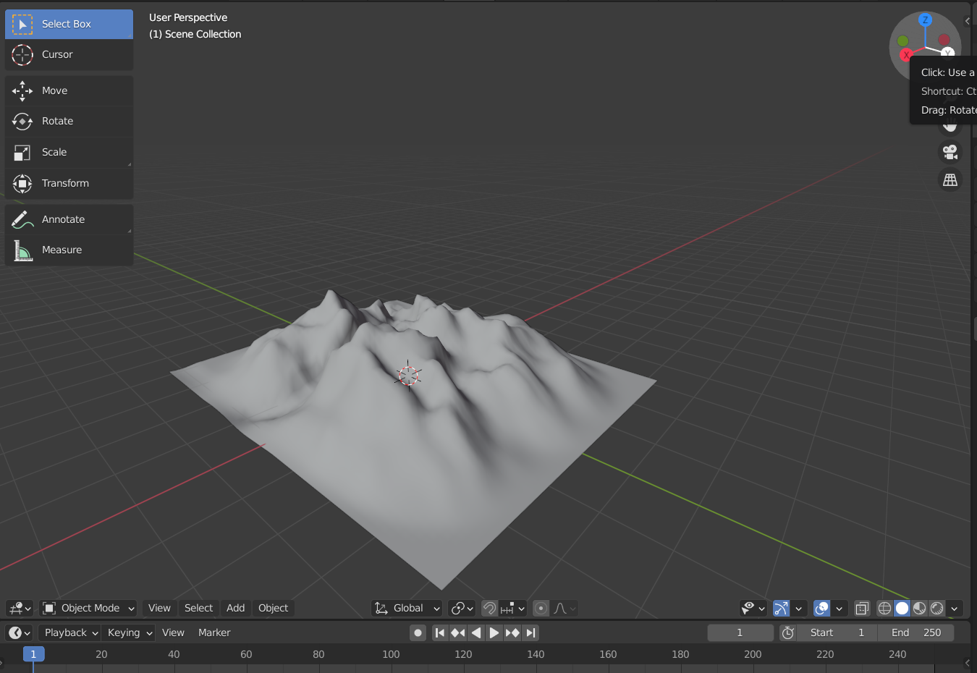

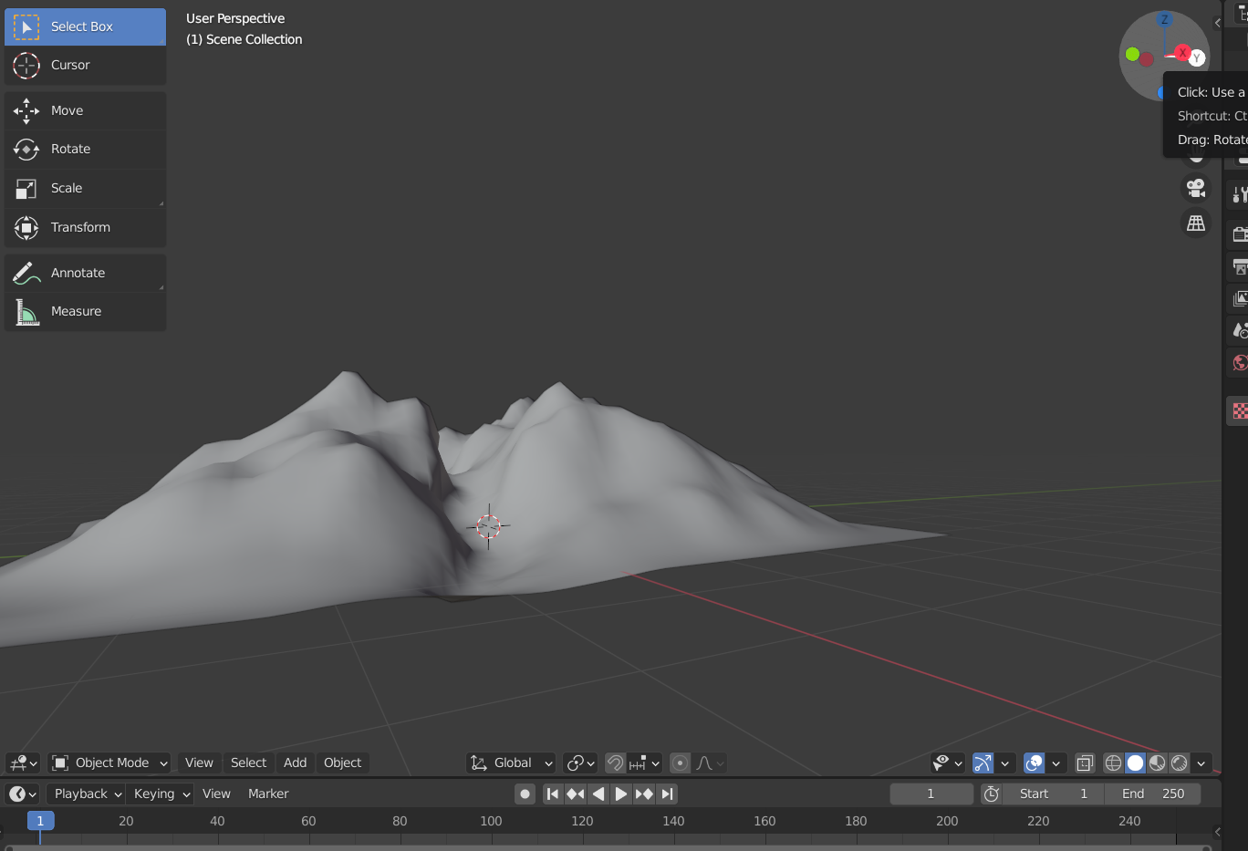

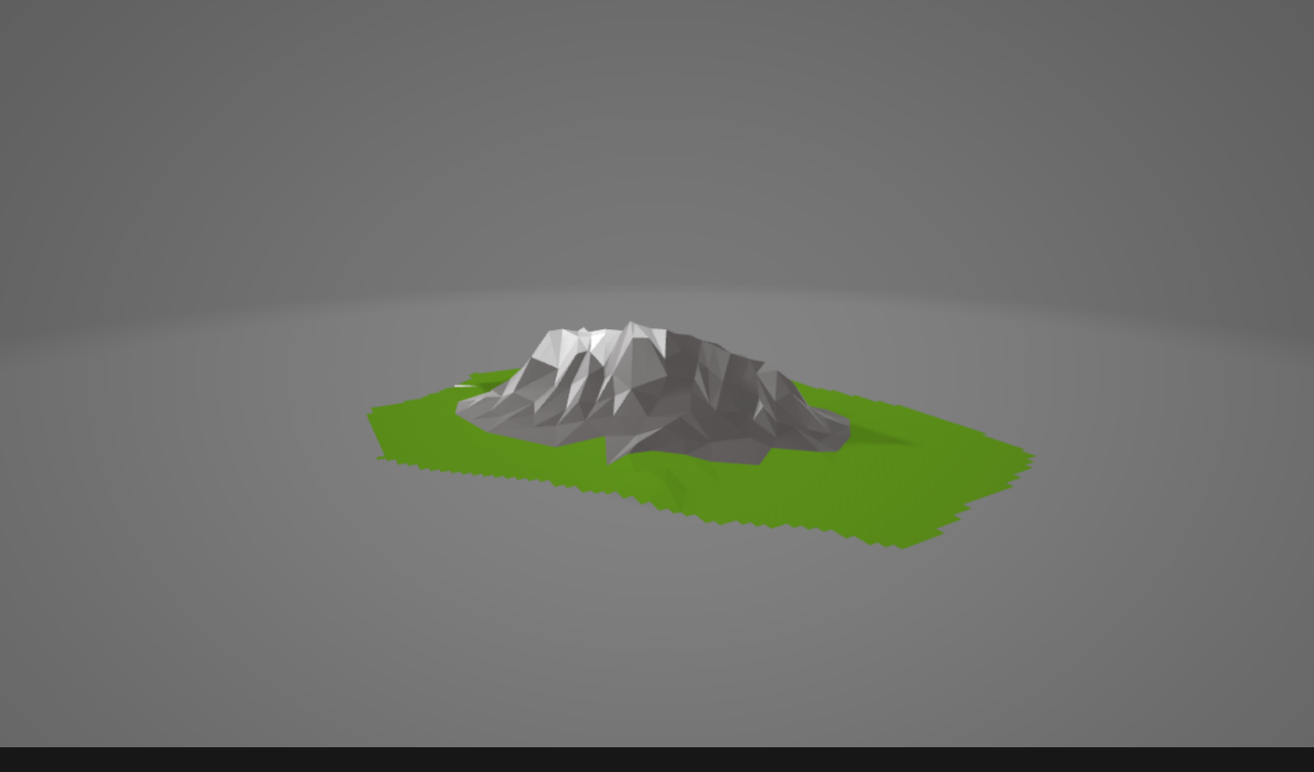

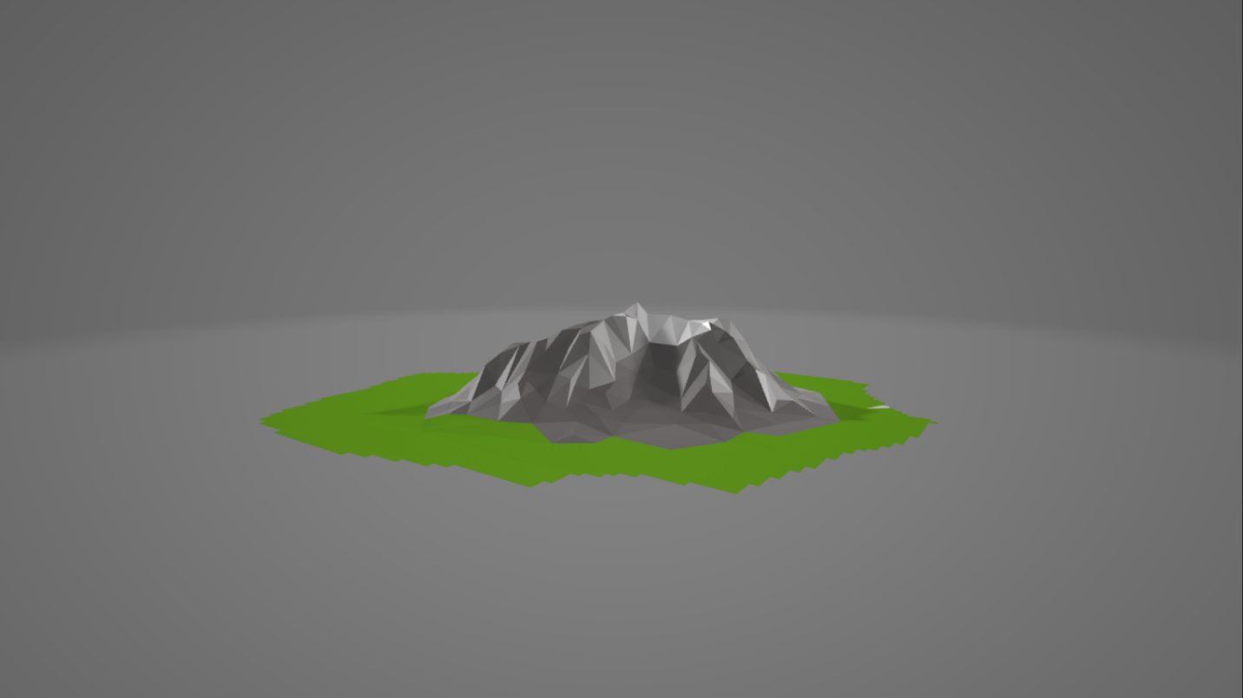

**Link:** [GAT Lab - Experiment 9 (All Files)](https://drive.google.com/drive/folders/16rwgj2Ehodbw5EWRNO1lybIXhRq8kY7-?usp=sharing)

**Conclusion:** Hence, we have designed an attractive 3D model of mountains.